# Delivery of Sprint – 3

**Node Red Connection to IBM Cloudant**

|  |  |
| --- | --- |
| **Date** | **18 November 2022** |
| **Team ID** | **PNT2022TMID26869** |
| **Project Name** | **Smart Waste Management for Metropolitan Cities** |

# Steps:

Node-RED Connection setup for data transmission from IBM Watson IOT platform to Node-REDdashboard

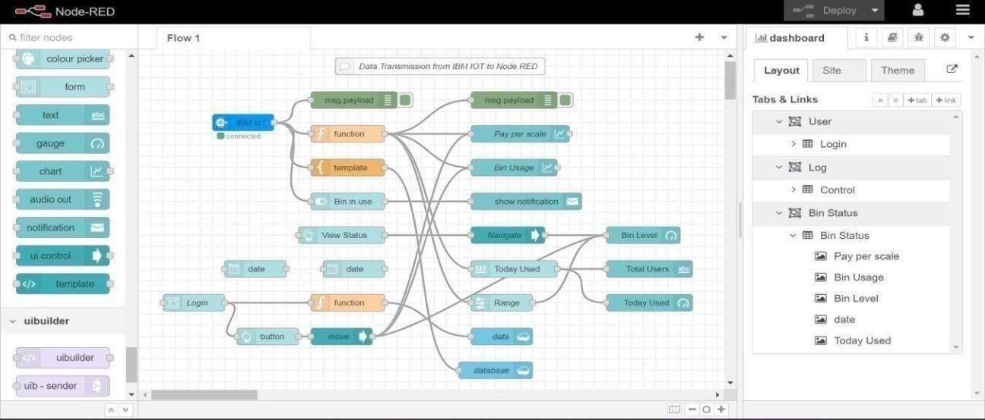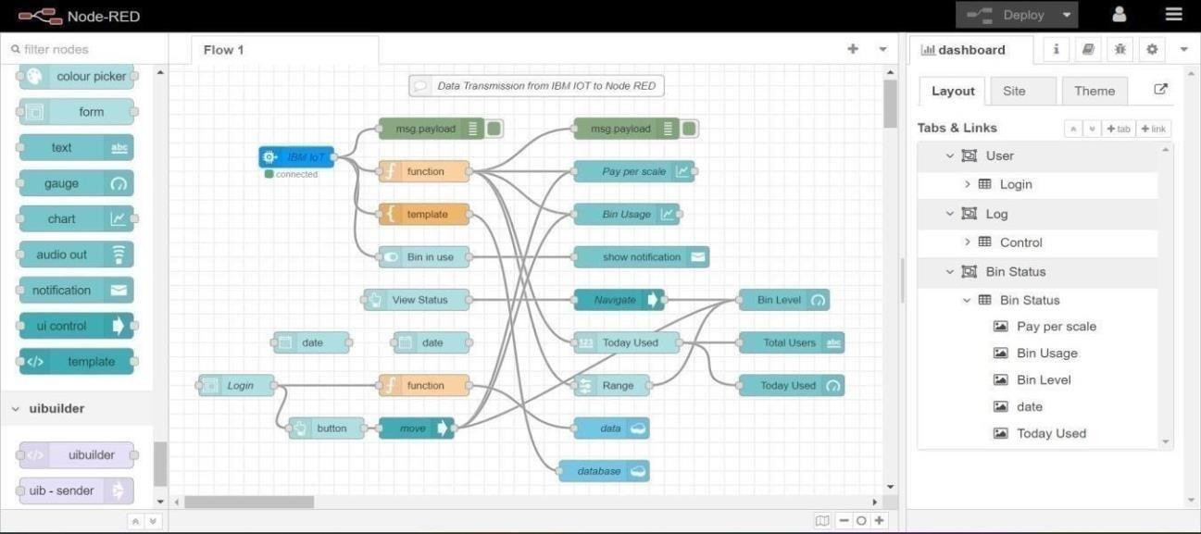

1. Simulate Wokwiconnection to transmit datafrom wokwiaccount to IBM Watson IOT platform and then to Node Red dashboard.

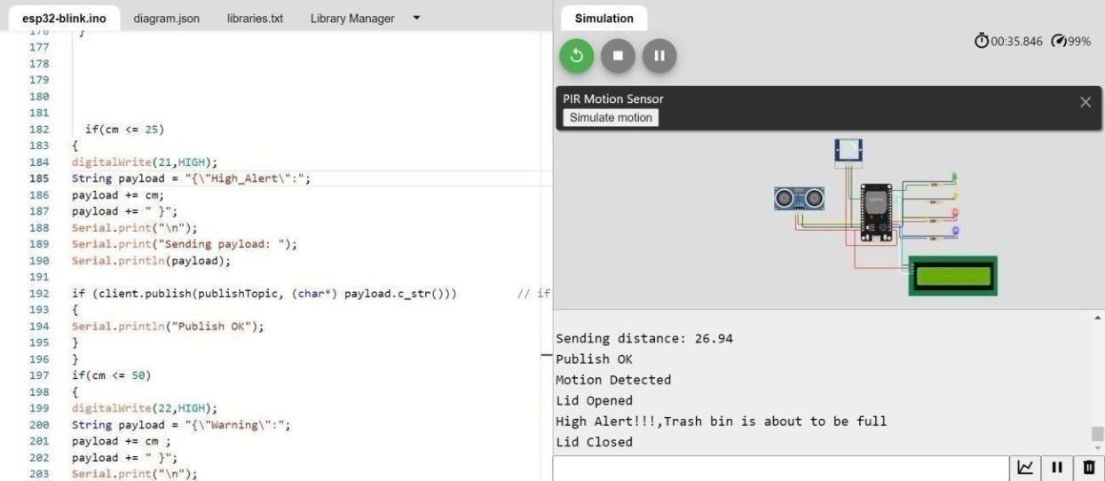

1. Data transfer to Watson IOTplatform.
2. Data transfer from IBM Watson IOTplatform and to Node red.

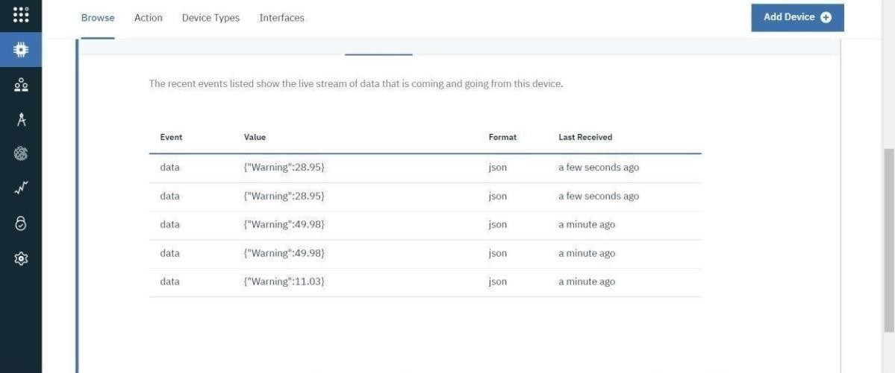

1. Storing database in IBM cloudant DB.

